Natural vs. Synthetic Antifungal Treatments
Student's Name
Institutional Affiliation
Date of Submission

Title
Effectiveness of Natural vs. synthetic antifungal treatments against Saccharomyces cerevisiae
Introduction
Due to the kept pace by the current antifungal drugs with the upcoming fungal infections medical demands, there is an increased need for new and effective medications. However, the discovery of antifungal medications is subjected to hindrances by the fungal and mammalian cells of evolutionary similarity. This case leads to non-selectivity and human homologs in fungal drug targets. In this case, our objective was to develop a natural method for antifungal treatment through the use of Saccharomyces cerevisiae distributed in six-well plates with the growth and treatment of the fungus halted since the antifungal substances active components impede crucial cellular procedures hence killing or limiting the development of the fungi.
Potential antifungal drugs' primary source still remains to be the natural products owing to the fact that both echinocandins and polyenes were obtained from natural microbial products. However, one of the significant challenges in discovering such drugs is identifying and purifying a compound challenge from a natural product complex extract. Our central hypothesis in the experiment was to identify critical life-history traits such as distribution, reproduction, tolerance, range, and diet. In our attempts to identify new natural products that were biologically active and produced in underexplored and unexplored ecological niches by actinomycetes, in this experiment, we assessed the feasibility of a bioassay that was throughput high for microbial extracts screening for natural antifungal products. In this case, we utilized the Saccharomyces cerevisiae yeast reporter strain, which heterologously produces HHk for microbial extracts screening for antifungal activity (Biological Sciences Department. 2019).
Background Information
Group III HHKs regulate virulence factors, sporulation, and morphogenesis in many fungal pathogens in humans such as C. Albicans as well as Blastomyces dermatitidis. HHKs' conversation and their mammals' absence throughout the kingdom of fungi enhance an attractive drug target. Hydrochloric Acid, 10Bleach, Tea Tree Oil, and Oregano Oil are antifungal substances whose ability for yeast reproduction rate inhibition is measured and tested through the yeast colonies' average numbers under each circumstance (Falleh et al. 2020). Saccharomyces cerevisiae yeast, on the other hand, reproduces at high rates and in short periods of time, and as well they are a perfect model organism. Additionally, the fungus serves as a model for other pathogenic fungi that are potentially harmful that has the capacity to affect plants or crops. Additionally, yeast is commonly found in dead organic materials and fruits and are heterotrophic, although some are also parasitic.
Methods and materials
In the experiment, we used Oregano oil, 4% bleach from the bottle, Tea Tree Oil, Hydrochloric acid, Saccharomyces cerevisiae yeast cell structure about 10^9 cells/ml supplemented plates for the fifteen Agar plates, 1000uL and 100uL micropipette, sterile Buffer solution. Vortex mixer, Microfuge tubes 2ml by eight sizes, microfuge tube stand, spinning stands for plating, and fifteen sterile tools applied to spread yeast (Broach, 2012).
The first procedure involves the original cell culture serial dilution applying a micropipette. With a sterile buffer solution, cells are diluted 10^-6, which will be carried out through the 100ul of 10^9 Saccharomyces cerevisiae culture addition to more buffer solution 900ul and overtaxing again leading to original culture dilution. For achieving the final 10^6 diluted solution 2ml, the dilution should be performed twice. For each treatment, each plate is labeled and given 100ul of its specific treatment except the control. Three plates should have 100ul of 4% bleach, another three with 100ul of 5% HCL, three containing 100ul TTO, three with 100ul oregano oil, and three control plates with no treatment up to fifteen plates in total.
100ul diluted cells might be applied after the treatment is applied to the plates and spread out using a spreader. For contamination avoidance, a new spreader should be applied to each plate. Finally, these samples are left for a week in a temperature-controlled environment lab where the colonies are counted and recorded after a one week period.
Results
In a throughout high manner, microbial extracts were screened against the antifungal expressing a strain of S. cerevisiae. Hydrochloric acid acted as a positive control since its action mode is known to require the HHKs group III expression (Artiga et al., 2017). Generally, our experiment's hypothesis was supported by the data. In this case, there was no growth of yeast on the oregano plates, bleach plates, or the tea tree plants. Growth was only evidenced in the HCL plates and the control plates. The reason for this was because hydrochloric acid was diluted until it was no longer toxic to the yeast. Additionally, there was no much growth on the control plates. This, therefore, implies that the used sample had an issue (Xiong et al.2020).
The Saccharomyces cerevisiae was seeded in 15 well plates having natural product extracts. After a week of incubation thirty degrees celsius, extracts that inhibited growth more tremendous than 50% were considered hit (Pagano et al.2019). The hits were assayed against S. cerevisiae strains to determine if they had a dependent activity for a secondary activity.
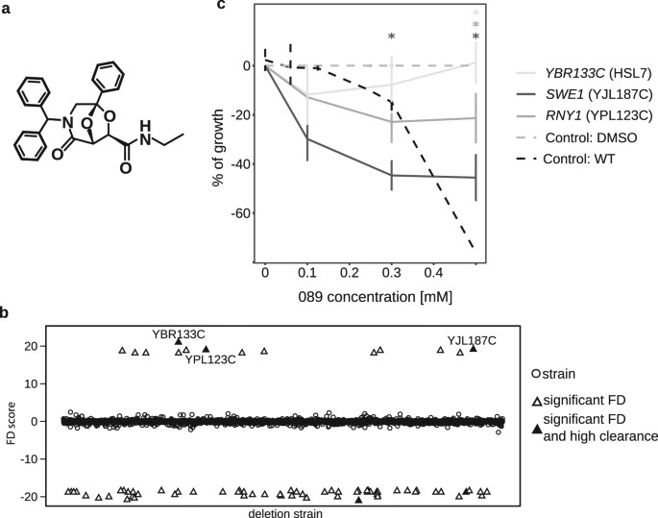
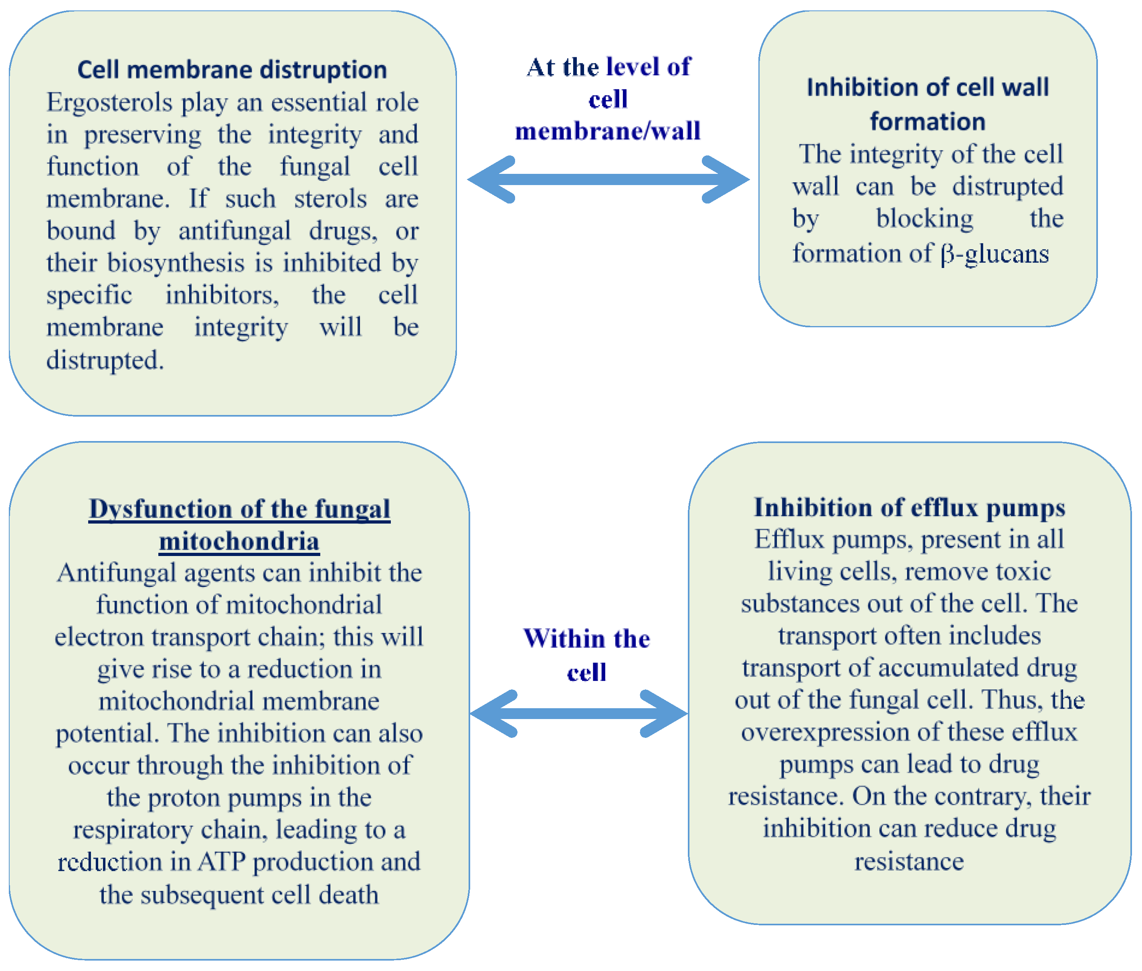

References
Artiga-Artigas, M., A. Acevedo-Fani, O. Martin-Belloso. 2017. Improving the shelf life of low-fat cut cheese using Nan emulsion-based edible coatings containing essential oregano oil and mandarin fiber. Food Control, vol. 76: 1-12, DOI: https://doi.org/10.1016/j.foodcont.2017.01.001
Biological Sciences Department. 2019. Biology 108: Organisms in their environment laboratory manual 2019/2020. Faculty of Arts and Science, MacEwan University, Alberta, Canada.
Broach, J.R., 2012. Nutritional Control of Growth and Development in Yeast. Genetics. Volume: 192(1): 73-105. DOI: 10.1534/genetics.111.135731
Copping, L. G., & H. G. Hewitt. 1998. Chemistry and Mode of Action of Crop Protection Agents. Royal Society of Chemistry. http://eds.b.ebscohost.com.ezproxy.macewan.ca /eds/ebook viewer/ebook?sid=a7a014f1-eb55-4ef0-ace1-c31ae6a88922%40pdc-v-sessmgr01&vid=0&format=EB
Falleh, H., M. Ben Jemaa, M. Saada, R. Ksouri. 2020. Essential oils: A good eco-friendly food preservative. Food Chemistry, vol. 330. DOI: https://doi.org/10.1016/j.foodchem.2020.127268
https://doi-org.ezproxy.macewan.ca/10.1016/j.foodchem.2017.04.172
Li, Y., X. Shao, J. Xu, Y. Wei, F. Xu, and H. Wang. 2017. Tea tree oil exhibits antifungal activity against Botrytis cinerea by affecting mitochondria. Food Chemistry 234: 62-67. DOI:
Pagano, L., Caldara, M., Villani, M., Zappettini, A., Marmiroli, N., & Marmiroli, M. (2019). In Vivo-In Vitro Comparative Toxicology of Cadmium Sulphide Quantum Dots in the Model Organism Saccharomyces cerevisiae. 9(4). https://doi.org/10.3390/nano9040512
Xiong, Y., SM. Li, RD. Warner, ZX. Fang. 2020. Effect of oregano essential oil and resveratrol nanoemulsion loaded pectin edible coating on the preservation of pork loin in modified atmosphere packaging. Food Control, vol. 114. DOI: https://doi.org/10.1016/j.foodcont.2020.107226

